**BUS, ITS ARCHITECTURE, and TYPES**

 **KIET GROUP OF INSTITUTIONS GHAZIABAD** 

**(An ISO – 9001: 2008 Certified & ‘A’ Grade accredited Institution by NAAC)**

**A.** **BUS**

**What is bus?**

* A bus is a set of wires that act a shared but common data path to connect multiple subsystems within the system.
* It consists of multiple lines, allowing the parallel movement of bits.
* The speed of the bus is affected by its length as well as by the number of devices sharing it.
* The size of a bus, known as its **width**, is important because it determines how much data can be transmitted at one time. For example, a 32-bit bus can transmit 32 bits of data, whereas a 64-bit bus can transmit 64 bits of data.
* Every bus has a **clock speed** measured in MHz or GHz. A fast bus allows data to be transferred faster, which makes applications run faster.
* An address bus is measured by the amount of memory a system can retrieve. A system with a 32-bit address bus can address 4 gibibytes of memory space. Newer computers using a 64-bit address bus with a supporting operating system can address 16 exbibytes or approx. 18446744073 GB of memory locations, which is virtually unlimited.

[**Note:1-GB** is defined as 1000³ bytes, whereas **1-GiB** is defined as 1024³ bytes.]

**Why the bus is required?**

* For communication and connections.
* The CPU communicates with the other component via a bus.
* Buses make it easy to connect new devices to each other and to the system.

**Advantages of Bus**

* Buses are low cost & very versatile.

**Disadvantage of Bus**

* At any one time, only one device (maybe it a register, the ALU, memory, or some other component) may use the bus. However, this sharing often results in a communication bottleneck.

**Examples of Buses:** Industry standards Buses e.g. ISA, EISA, SCSI, and PCI

**B. BUS ARCHITECTURE**

Devices share the bus, because of this sharing, the bus protocol (set of usage rules) is very important. Typical bus architecture consists of

1. Data lines,

2. Control lies,

3. Address lines,

4. Power lines.

 **KIET GROUP OF INSTITUTIONS GHAZIABAD** 

**(An ISO – 9001: 2008 Certified & ‘A’ Grade accredited Institution by NAAC)**

**a. Data lines**

* The lines of a bus dedicated to moving data are called the data bus.
* These data lines contain the actual information that must be moved from one location to another.

**b. Control lines**

* They indicate which device has permission to use the bus and for what purpose (reading or writing from memory or from an input/output (I/O device, for example).
* These lines also transfer acknowledgements for bus requests, Interrupts, and clock synchronization signal.

**c. Address lines**

* These lines indicate the location (e.g. in memory) that the data should be either read from or written to.

**d. Power lines**

* These lines provide the electrical power necessary.

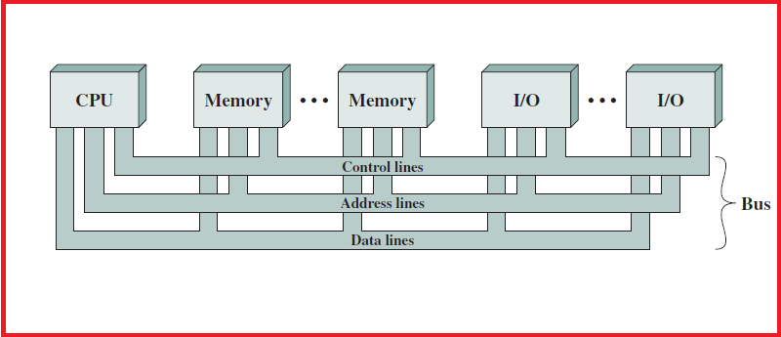

**Figure 1: Bus Architecture/Bus Interconnection Scheme**

 **KIET GROUP OF INSTITUTIONS GHAZIABAD** 

**(An ISO – 9001: 2008 Certified & ‘A’ Grade accredited Institution by NAAC)**

**C. TYPICAL BUS TRANSACTIONS**

It includes

a) sending an address (for a read or write).

b) transferring data from memory to a register (a memory read).

c) transferring data to the memory from a register (memory write).

* Buses are used for I/O reads and writes from peripheral devices. Each type of transfer occurs within a bus-cycle, the time between two ticks of the bus clock.

**KIET GROUP OF INSTITUTIONS GHAZIABAD** 

**(An ISO – 9001: 2008 Certified & ‘A’ Grade accredited Institution by NAAC)**

**D.** **TYPES OF BUSES**

**a. Point-to-Point Bus**

* A bus can be point-to-point, connecting two specific components.

**b. Multipoint Bus**

* It can be a common pathway that connects a number of devices, requiring these devices to share the bus.

**c. Processor -Memory Bus**

* These buses are short, high-speed buses that are closely matched to the memory system on the machine to maximize the bandwidth (transfer of data) and are usually design specific.

**d. I/O Bus**

* These buses are typically longer than processor-memory buses and allow for many types of devices with varying bandwidth.
* These buses are compatible with many different architectures.

**e. Back Plane Bus**

It is actually built into the chasis of the machine and connects the processor, the I/O devices, and the memory (So all device are one bus).

**f. Dedicated and Multiplexed Bus**

|  |  |  |
| --- | --- | --- |
| **Types of Bus** | **Dedicated Bus** | **Multiplexed Bus** |
| **Explanation** | A dedicated bus is permanently assigned either to a particular function or to a physical subset of computer components.  **Functional Dedication** means a separate bus for each different function.  **Physical Dedication** means use of separate buses connecting different system components (same functionality). | Common bus used for both data and address transmission.  Presence of a Control Line: Address valid signal.   * Activate address valid control line. * Place address on multiplexed bus. * Modules check if the address refer them. * After sometime, address removed. * Data is now sent on this bus. |
| **Advantages** | High Throughput and Less Waiting Time | Use of fewer lines -> Less Cost and Space |
| **Disadvantages** | More Cost (Larger Bus Size) | Reduced Performance-> More Complex Circuit |

**KIET GROUP OF INSTITUTIONS GHAZIABAD** 

**(An ISO – 9001: 2008 Certified & ‘A’ Grade accredited Institution by NAAC)**

**g. Single Bus and Multiple Bus**

All computing devices, from smartphones to supercomputers, pass data back and forth along electronic channels called "buses." The number and type of buses used strongly affect the machine's overall speed. Simple computer designs move data on a single bus; multiple buses, however, vastly improve performance. In a multiple-bus architecture, each pathway is suited to handle a particular kind of information.

**Distinguishing features of** **Single Bus and Multiple Bus**

**1. Speed and Efficiency**

In a single-bus architecture, all components including the central processing unit, memory and peripherals share a common bus. When many devices need the bus at the same time, this creates a state of conflict called bus contention; some wait for the bus while another has control of it. The waiting wastes time, slowing the computer down. Multiple buses permit several devices to work simultaneously, reducing time spent waiting and improving the computer's speed. Performance improvements are the main reason for having multiple buses in a computer design.

**2. Expansion**

Having multiple different buses available gives you more choices for connecting devices to your computer, as hardware makers may offer the same component for more than one bus type. For example, most desktop PCs use the Serial Advanced Technology Attachment interface for internal hard drives, but many external hard drives and flash drives connect via USB. If your computer's SATA connections are all used, the USB interface lets you connect additional storage devices.

**3. Compatibility**

As with all of a computer's components, bus designs evolve, with new types being introduced every few years. For example, the PCI bus that supports video, network and other expansion cards predates the newer PCIe interface, and USB has undergone several major revisions. Having multiple buses that support equipment from different eras lets you keep legacy equipment such as printers and older hard drives and add newer devices as well.

**4. Multi-core**

A single central processing unit places heavy demands on the bus that carries memory data and peripheral traffic for hard drives, networks and printers; since the mid-2000s, however, most computers have adopted a multi-core model that require additional buses. To keep each core busy and productive, the new bus designs ferry increased amounts of information in and out of the microprocessor, keeping wait times to a minimum.

**KIET GROUP OF INSTITUTIONS GHAZIABAD** 

**(An ISO – 9001: 2008 Certified & ‘A’ Grade accredited Institution by NAAC)**

**E. CLASSIFICATION OF BUSES ON THE BASIS OF PERSONAL COMPUTER**

**a. Internal/System Bus**

* These buses connect the CPU, memory, and all other internal components.

**b. External/Expansion Bus**

* The buses connect external devices, peripherals, expansion slots, and I/O ports to the rest of the computer.
* These buses are slower but allow for more generic connectivity.

**c. Local Buses/Data Bus**

* These buses connect a peripheral device directly to the CPU.
* These high - special buses can be used to connect only a limited number of similar devices.